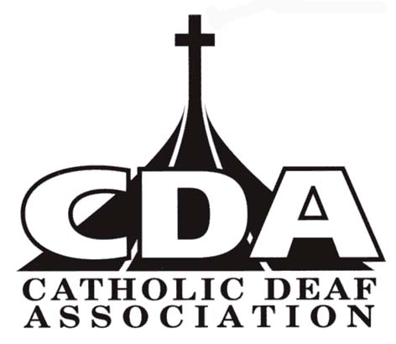
CATHOLIC DEAF ASSOCIATION
Email: secretary@catholicdeaf.org.uk

CDA membership
Your name _________________________________________________________________________________________________
Your address __________________________________________________________________________________________________
___________________________________________________ Post Code _________________________________________________
Email ________________________________________________________________________________________

Individual membership (one year) | £15.00 for 1 year
Individual membership (three years) | £40 for 3 years
Family/Couple membership (one year) | £25.00 for 1 year
Family/Couple membership (three years) | £65.00 for 3 years
I wish to donate towards the work of the Catholic Deaf Association

Total | £

I wish to pay CDA membership by CHEQUE or BACs (please circle)

Cheque payable to CATHOLIC DEAF ASSOCIATION or by BACs (Sort code 82-12-08; Account 60271979)

CDA membership will support the work of the CDA. All news, photographs, videos on www.catholicdeaf.org.uk

Signature: ……………………………………………………..…………….. Date ………………………………..

Please return this form to
CDA Secretary, Flat 30 Rivington, Cholmondeley Road, Salford M6 8QH
Registered Charity No 262362

